Eastern Philosophy Discussion
Name
Institution
Date

Eastern Philosophy Discussion - Wabi-Sabi
Wabi refers to the beauty found in imperfect things, while Sabi relates to the beauty found in things that age in time and show the impermanence of objects, situations, and even life. The combination of the two words refers to the natural beauty of things in the physical environment.
The selected images are as follows:
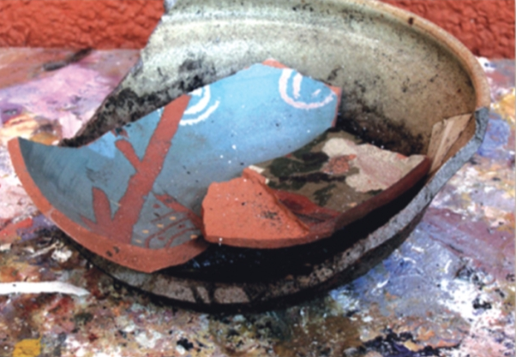 Between (encaustic on wood panel) by Serena Barton. Image retrieved from https://www.artistsnetwork.com/art-mediums/back-porch-inspiration-wabi-sabi-painting/
To other eyes, it is a broken bowl with traces of dust or mad or black paint. The broken pieces lie inside the remaining unbroken part of the porcelain bowl. In other ways, there is beauty that oozes from the design and the posture. Wabi-sabi doesn't require an explanation as to why there is a draw to a certain thing. It also reminds us of the natural cycle of things to reach a point where they are deemed unpleasant. If the bowl is appreciated when it is of high value, why can't it still have value when broken? Even with the chip on a mug, it still has beauty in its imperfections.
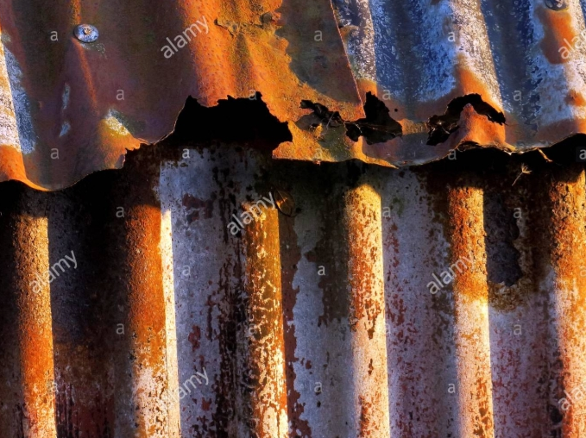 Image retrieved from Google https://www.alamy.com/wabi-sabi-a-japenese-culture-of-the-natures-passage-of-time-showing-beauty-in-the-art-of-imperfection-and-impermanence-this-image-is-a-section-of-rus-image262636615.html
This image presents a structure with rusted iron sheets which could have been due to the acidic rain or the end of its use. The iron sheet has crafted holes with rusted nails holding it together. Its imperfection may come because of its color. Certain parts of the iron sheet are white. At first, it may seem too old and ugly, but according to the wabi-sabi analogy, there is beauty in the processes. The iron sheet was new, as it depreciated, it became old due to the decay shown by the rust on it. Just like the rusted edges, the youthfulness and old age of our life is not permanent and there is a need for embracing the imperfections. If enjoying the benefits from the material while still new, there should be a natural embrace at its age.

